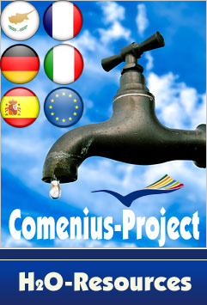

RESULTS FROM SPAIN

- AGE AND GENDER
AGE |  | male | female
Under 12 | - | 50 52.8% | 46  47.91%
12 | 20 | 50 52.8% | 46  47.91%
13 | 33 | 50 52.8% | 46  47.91%
14 | 9 | 50 52.8% | 46  47.91%
15 | - | 50 52.8% | 46  47.91%
16 | 3 | 50 52.8% | 46  47.91%
17 | 11 | 50 52.8% | 46  47.91%
18 | 18 | 50 52.8% | 46  47.91%
Over 18 | - | 50 52.8% | 46  47.91%

- TYPE OF HOUSING:

 |  |  | owned house | rented house
house for one family | 39 | 40.625% | 82.29% | 17.7%
flat | 16 | 34.375% | 82.29% | 17.7%
semi-detached house | 18 | 18.75% | 82.29% | 17.7%
others | 6 | 6.25% | 82.29% | 17.7%

- NUMBER OF PEOPLE LIVING AT HOME

In my home there are __________ people

2 people | 5 | 5.21%
3 | 11 | 11.46%
4 | 44 | 45.83%
5 | 24 | 25.00%
6 | 11 | 11.46%
7 | 1 | 1.04%

- Please ask in your family: how much water you need in one year (2008)?

In my home we need all together __________ m³ fresh water in a year.
Total m³ = 21520 x = 275.8 m³ per family

- Please ask in your family: how much you pay for water in one year (2008)?

In my home we pay for fresh water __________ EUR.

Total in € 28027 x = 373.6 € per family

- Have you ever had the problem that no water came out of the tap?
No □ 87 (90.63%) Yes □ How many times a year? 9 (9.37%) twice

- Do you talk to your parents about “Saving water ”?
No □ 52(54.16%) Yes □ 44(45.84%)

- Do you personally and actively save water?
No □ 29 (30.2%) Yes □ 67 (67.79%)

- Do you think that SAVING WATER is necessary in the future?
No □ - Yes □ 96 (100%)

The project group H2O-Resources (11.02.2010)

